Recursive Master Theorem

It is Third Approach of Solving Recursive Method like Substitute & Tree method

This Approach is widely we used out of 70% we use this Approach.

Becozz it is Simplicity and Easy Get the Time Complexity .

If we don’t apply Master theorem on our problem then only we use Substitute or Tree Method .

The Problem is :

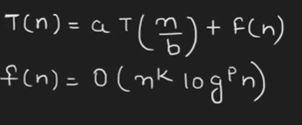

Here we find two things

1. Log ba
2. K

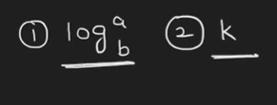

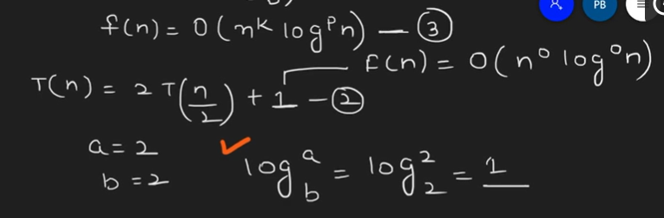

Where k = 0

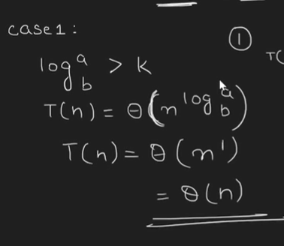

Average Case Theta 🡺 Θ (n)

Problem 2 :

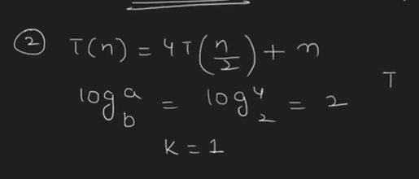

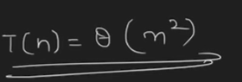

Average Case Theta 🡺 Θ (n2)